We need to clear up the static keyword mess b4 we move on:
1. Persistence: When a local variable within a function is declared static, it retains its value between successive calls to that function. Unlike regular local variables which are re-initialized each time the function is called, a static local variable is initialized only once and its value persists across calls.
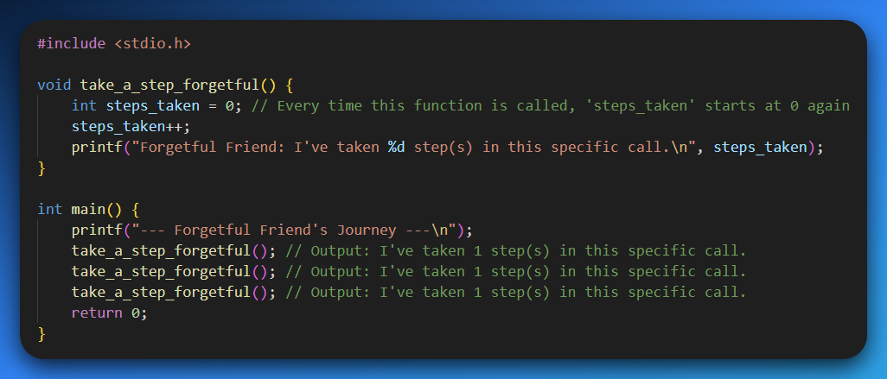
Think of take_a_step_forgetful() like a brand new sticky note you use every time you want to mark something. You write "1" on it, then you throw it away. The next time you need to mark something, you grab a new sticky note and write "1" on that one too. It never remembers the previous counts because you keep starting fresh.
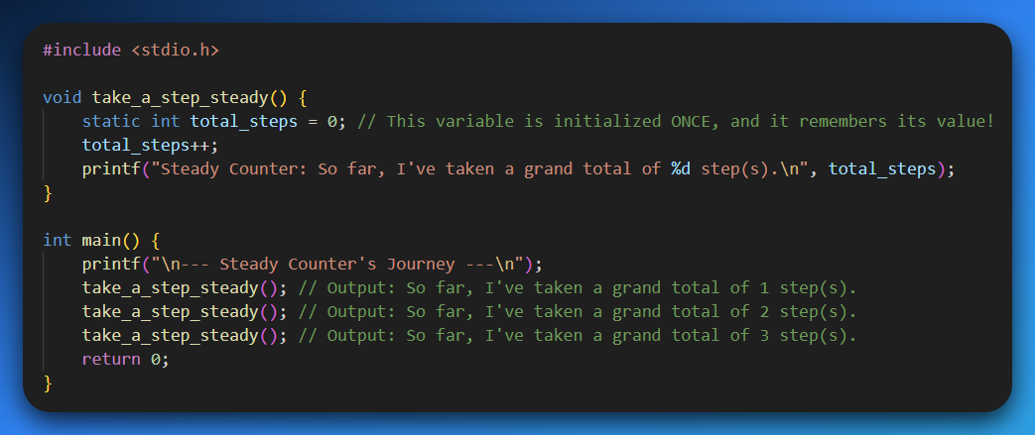
Now, take_a_step_steady() is like a real, physical clicker counter you use for events. The first time you use it, it's at zero. You click it once, it shows "1". You put it down. The next time you pick it up, it's still at "1", and when you click it again, it goes to "2". It keeps its count because it's the same clicker, not a new one each time.

2. Limited Scope: Although a static local variable persists in memory, its scope remains limited to the function in which it is declared. It cannot be directly accessed from outside that function.
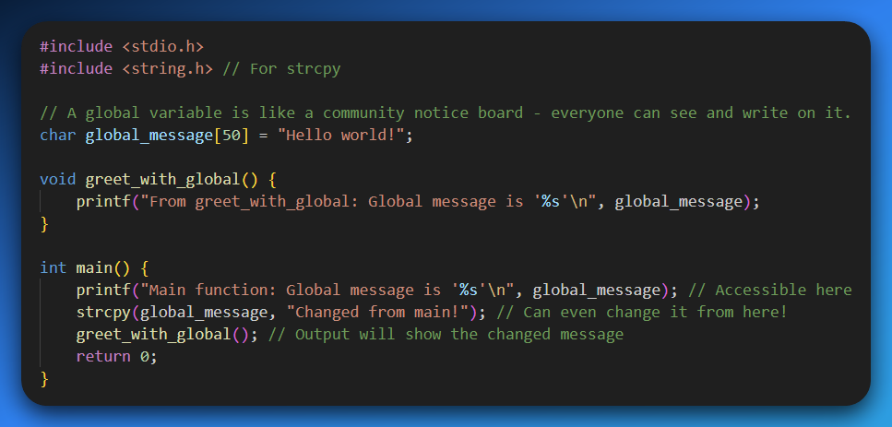
The global_message is like a big whiteboard in the common room. Anyone walking by can read it, and anyone can scribble something new on it. It's public.
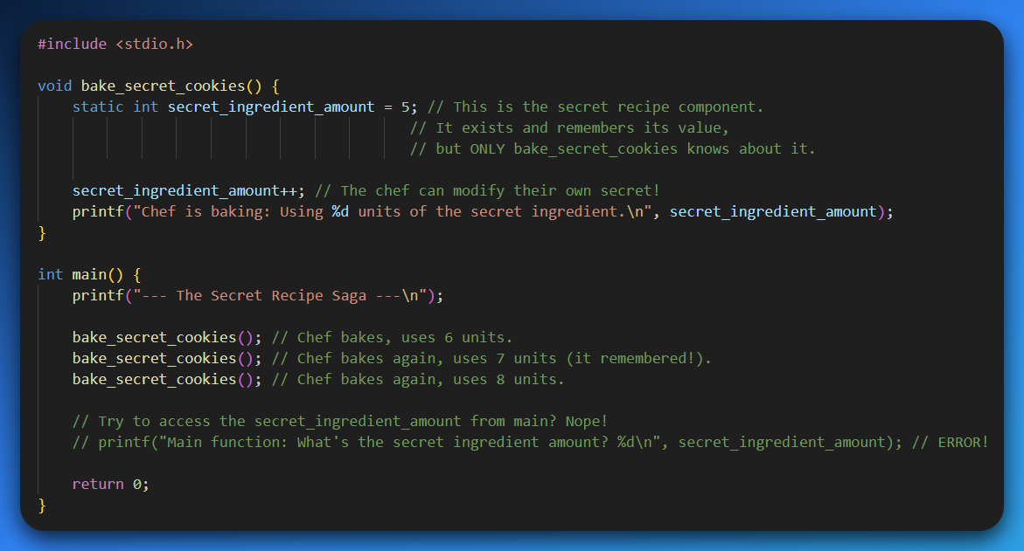
Now, a static local variable is like a chef's secret recipe. The recipe exists, it persists (they don't forget it after one batch of cookies!), but it's kept inside their head, or in a locked safe within their kitchen. No one outside that kitchen (the function) can just walk in and look at it directly.
It's like trying to ask your neighbor for your secret recipe when they've never even been to your kitchen. They don't know what you're talking about!

3. Global Static Variables: When a global variable (declared outside any function) is declared static, its visibility is restricted to the specific source file (translation unit) in which it is defined. This prevents other source files from directly accessing or modifying it, promoting modularity and preventing naming conflicts.
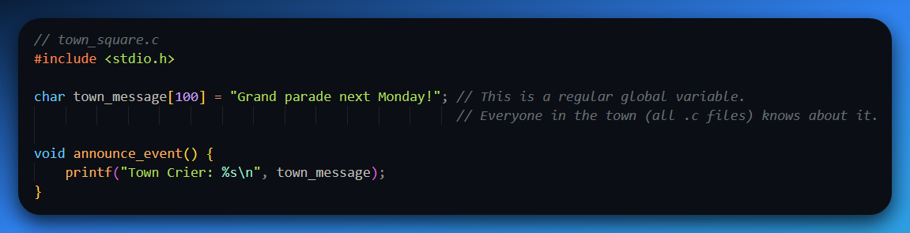
Above is a regular global variable (declared outside any function, without static) is like a town crier. When the town crier shouts a message, everyone in the town hears it. Any neighborhood, any house, anyone can listen and react, and even shout back to change the message.
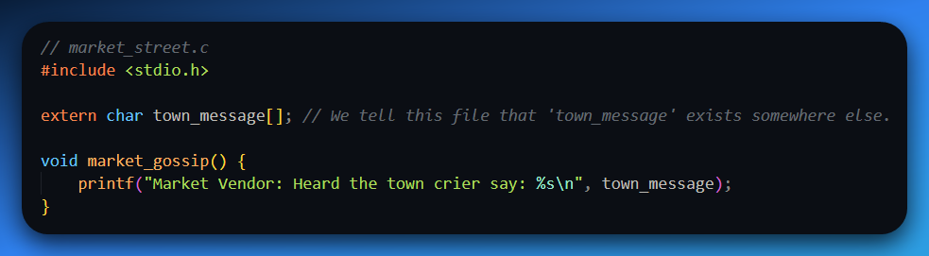
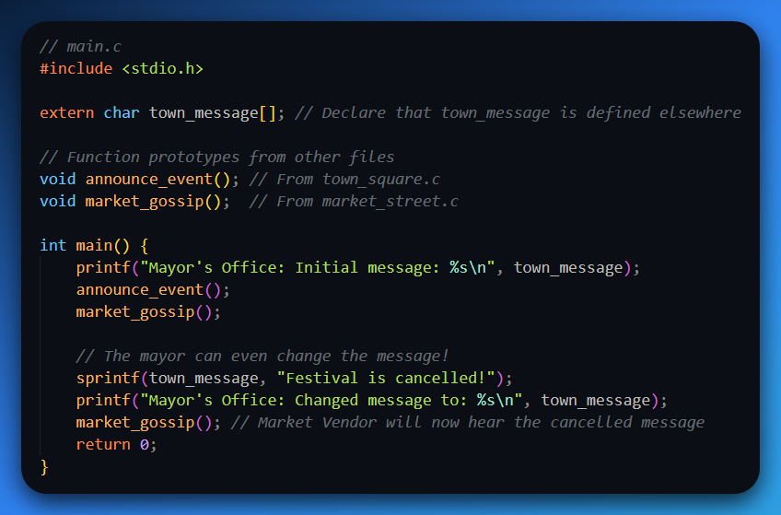
Above we can see that town_message was a regular global, any .c file could extern it and access and modify it. This can lead to chaos. Imagine market_street.c and town_square.c both trying to change town_message for different reasons. It's a recipe for confusion and hard-to-find bugs!

Now, when a global variable is declared static, it's like the notes from a private meeting of a specific neighborhood watch group.
Those notes are important for that group's operations (they persist), but they are only visible and accessible within that specific neighborhood (that .c file).
No one from the next neighborhood over can peek at those notes directly, even if they know the neighborhood exists.
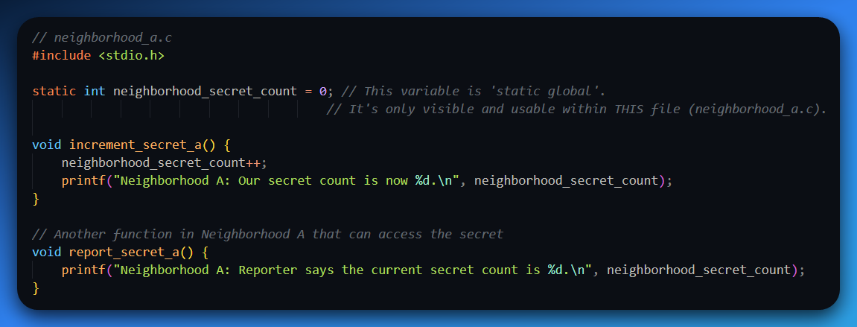
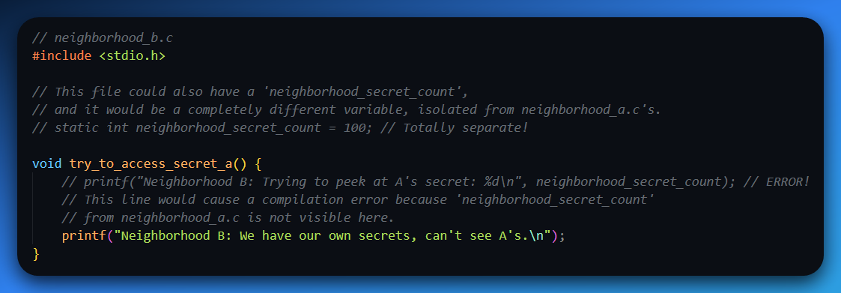
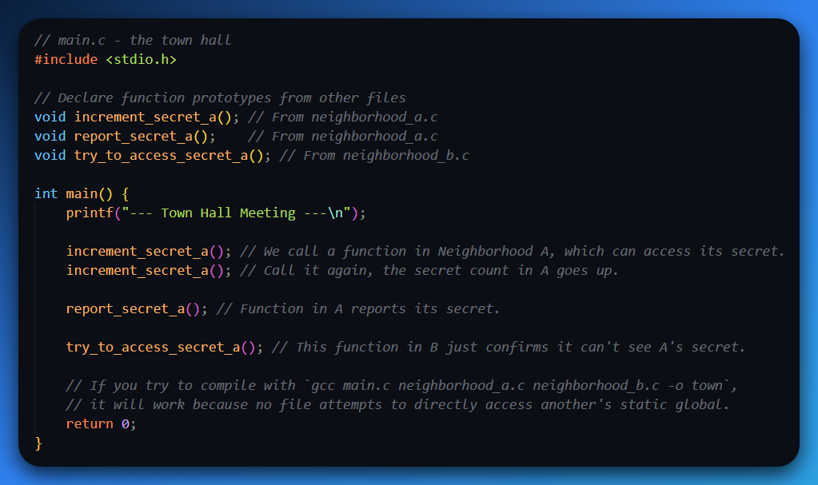
Why this is a big deal for you, especially in reversing and malware analysis:
- Modularity: When you're building large software (or analyzing it!), you want to break it into manageable pieces. static global variables help you build self-contained "modules" (your .c files) where certain data is truly private to that module. This makes the code easier to understand, debug, and maintain. It's like having well-defined departments in a company – each department manages its own internal files and doesn't expose them to everyone else unless necessary.
- Preventing Naming Conflicts: Imagine two different developers independently writing two .c files for the same project, both deciding to use a global variable named config_value. If they were both regular global variables, the linker would scream about a "redefinition" error. But if both declare their config_value as static global, they are completely separate variables, each private to its own file. No conflict! This is super useful in complex projects where many people might be contributing.
So, while a static local variable gives a function a private, persistent memory, a static global variable gives an entire source file (or "translation unit") its own private, persistent data that can't be seen or touched by other source files. This is fundamental for robust, scalable software architecture.

4. Memory Allocation: Static variables are allocated in the data segment of memory, not on the stack like automatic variables. They exist for the entire duration of the program's execution.
Alright, let's dive into where these variables actually live in your computer's memory! This is foundational for understanding how programs actually run and manage their data.
Your computer's memory isn't just one big blob, but a city divided into different neighborhoods, each with its own vibe and purpose for storing data.
Most of the time, when you declare a variable inside a function without any special keywords (these are called "automatic variables"), they live on the stack.
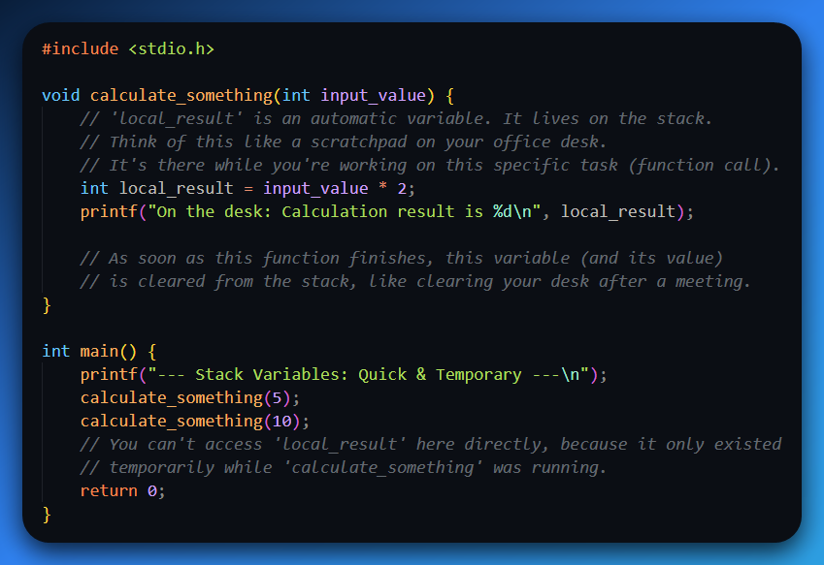

Now, static variables (whether they are local to a function or global to a file) don't go on the stack. They're allocated in a different memory neighborhood called the data segment.
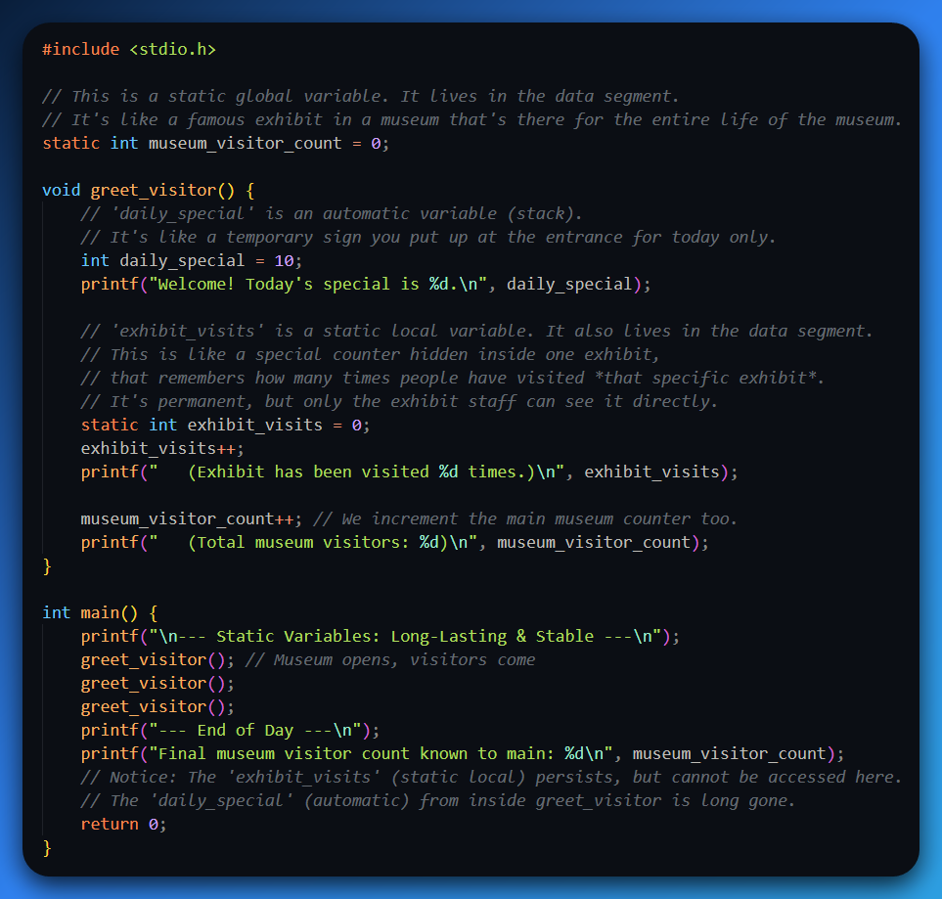
The data segment is like a permanent archive or a museum. Once an item is placed there (a static variable is declared), it stays there for the entire time the "museum" (your program) is open.
It doesn't get cleared away when a specific "tour group" (function call) finishes. It's allocated once at the very beginning of the program's life and is only removed when the program completely shuts down.

Why does this matter?
Lifetime:
- Automatic (Stack): Variables on the stack have a local lifetime – they are created when the function is called and destroyed when it returns.
- Static (Data Segment): Variables in the data segment have a global lifetime – they are created when the program starts and destroyed when the program ends. This is why they can retain their values across multiple function calls.
Speed vs. Size: The stack is super fast for allocation and deallocation because it's just moving a pointer up and down. The data segment is for things that need to be there consistently.
Predictability for Reversing: When you're reverse engineering, understanding where data lives (stack vs. data segment) helps you track its persistence.
If you see a piece of data that seems to survive across different parts of a program, it's a good bet it's a static variable or something allocated in the heap (another memory region, but that's a story for another day!). Malware often uses static variables for configuration data, flags, or persistent counters.

5. Static Functions: When a function is declared static, its visibility is limited to the source file (translation unit) in which it is defined. This means the function cannot be called from other source files. This is useful for creating helper functions that are only intended for internal use within a specific module, preventing name clashes and promoting encapsulation.

